# OLAP Reports

For Brazos University, the business questions under consideration can be categorized into various functional areas as follows. This section illustrates in detail each of the business question and the associated OLAP reports from SSAS.

* Facilities
* Admissions and Finance
* Course Registration and Revenue
* Placements

Before going into the details of individual cube and report development. The following section details the creation of Data Source and Data Source View.

## Defining Data Source and Data Source View

### Create a new Project

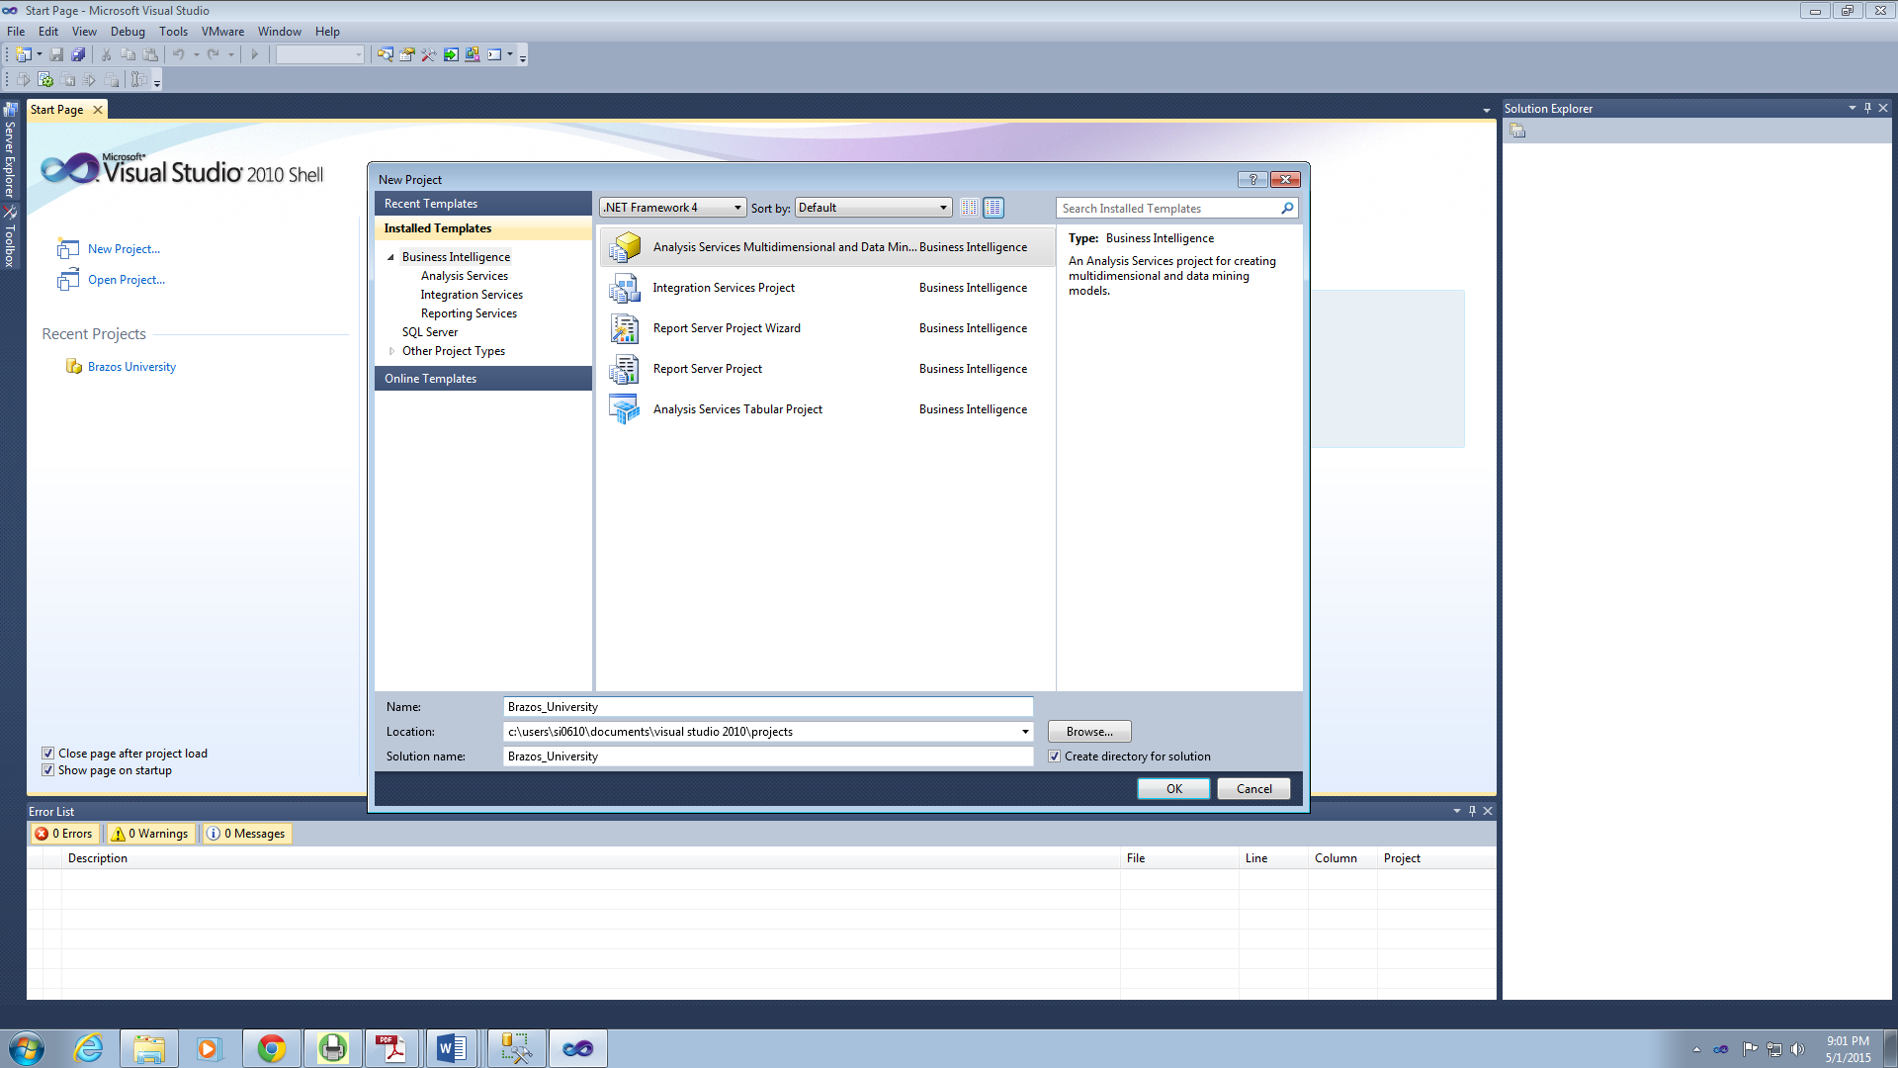

### Add New Data Source

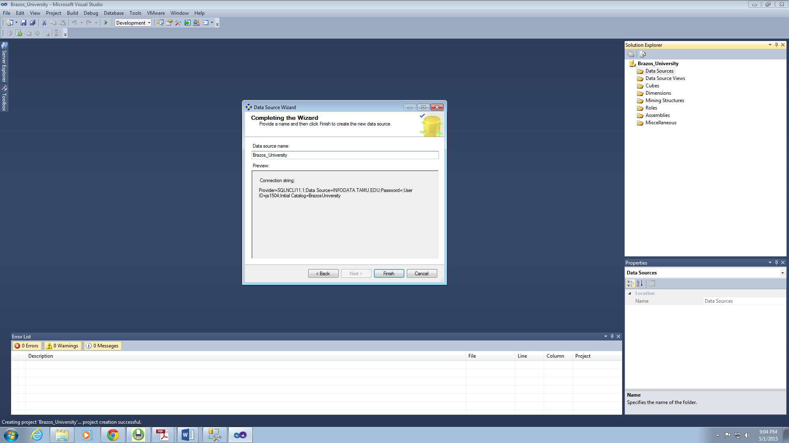

### Create Data Source View

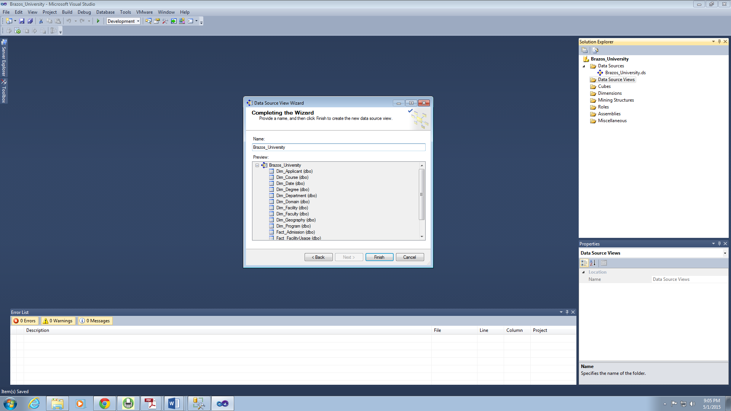

## Creating Cubes and Reports

### Facilities

#### Cube Structure

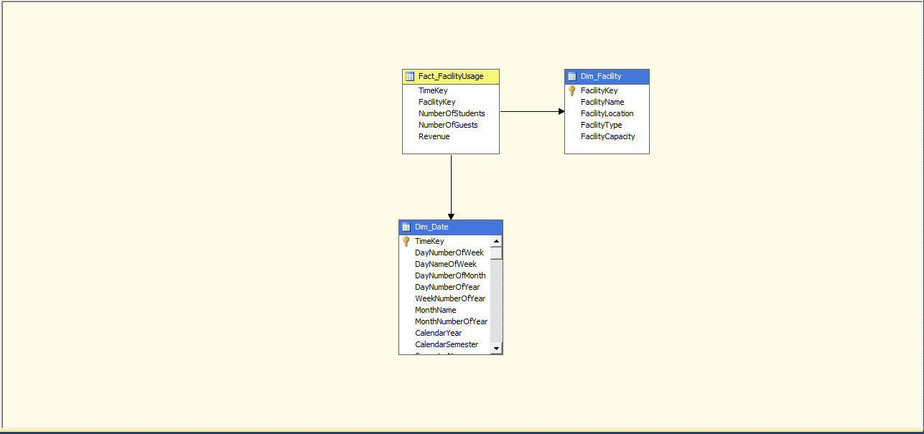

#### Hierarchies

Facility Hierarchy

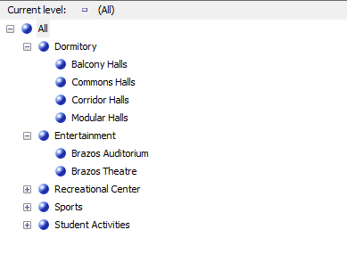

Date Hierarchy

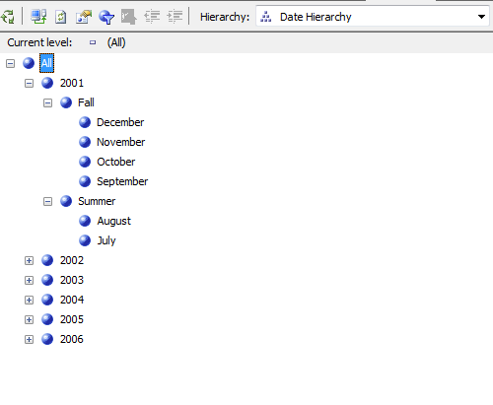

#### Reports

**Business Question:** Number of Students and Guests who have used Dormitory facilities during summer of 2001 and the comparison between each of the dormitory halls

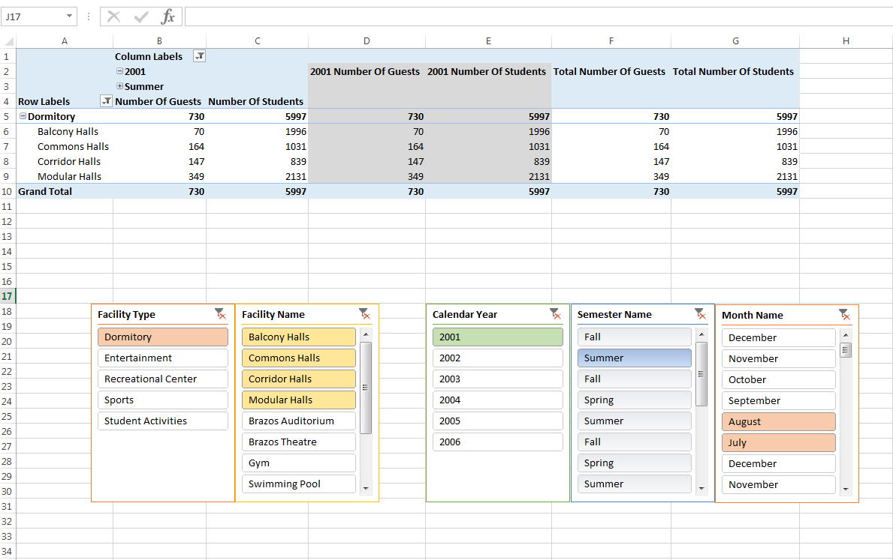

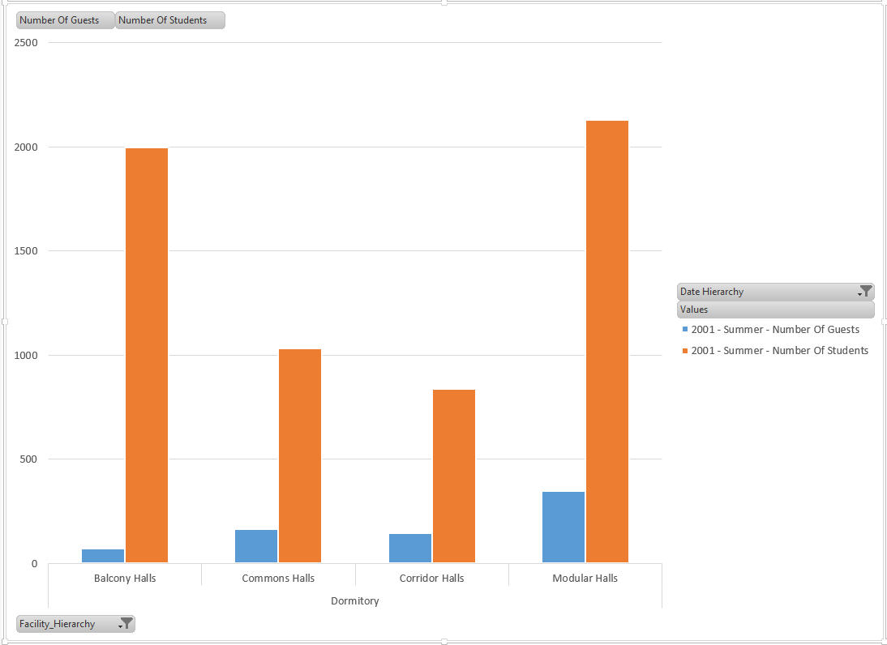

**Business Question:** Identify thetrends in Gym usage for the year 2004

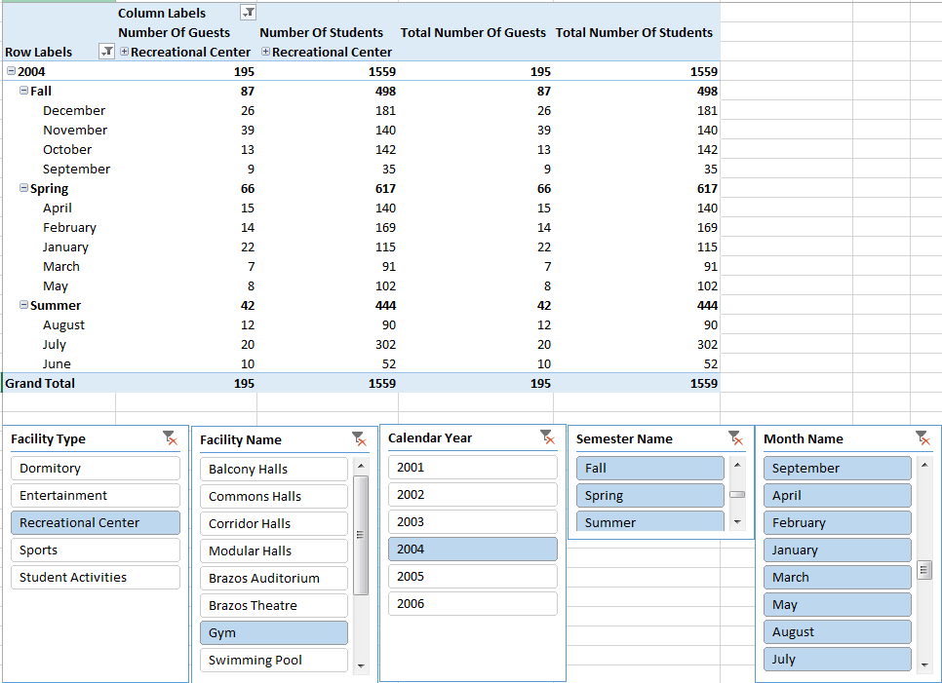

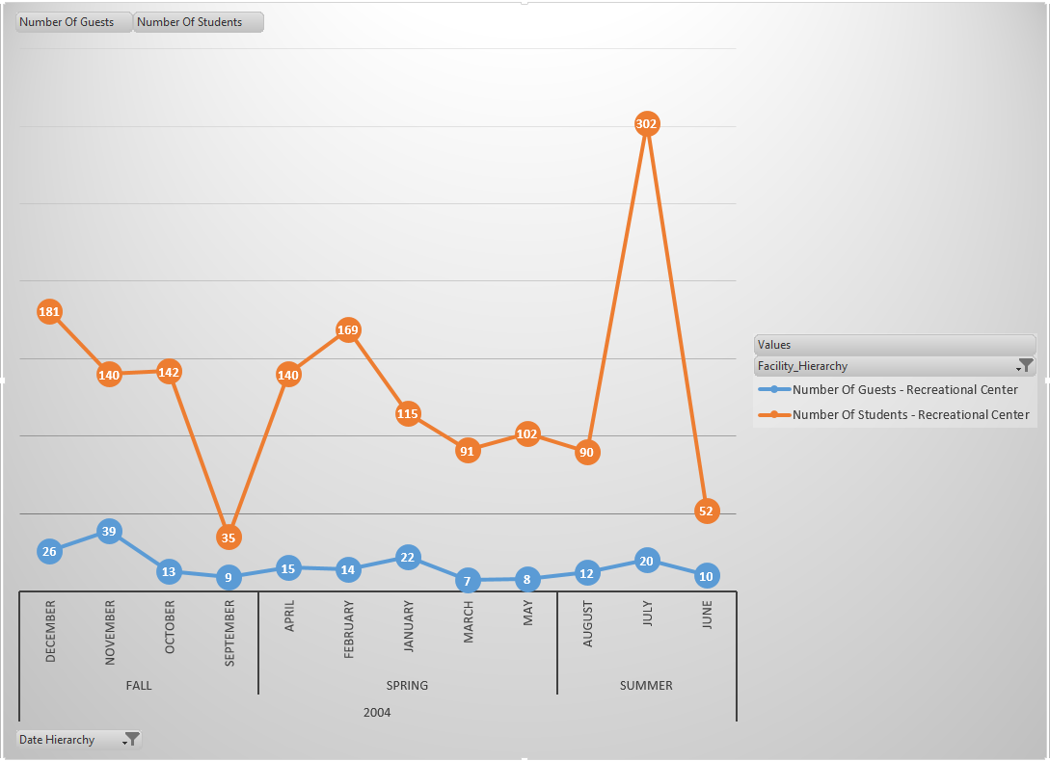

The above reports on facility usage are helpful for the management in understanding the trends in facility usage. Based on this, the university management will be able to make strategic decision on how when and where to improve the infrastructure of the facilities. For example from the first graph it can be observed that though there are greater number of students who prefer to stay in Balcony halls, relatively only a very few number of guests choose to stay at these halls. This insight will help into analyzing the underlying problems, for example facilities, associated with these dormitory halls.

### Admissions and Financial aid

#### Cube Structure

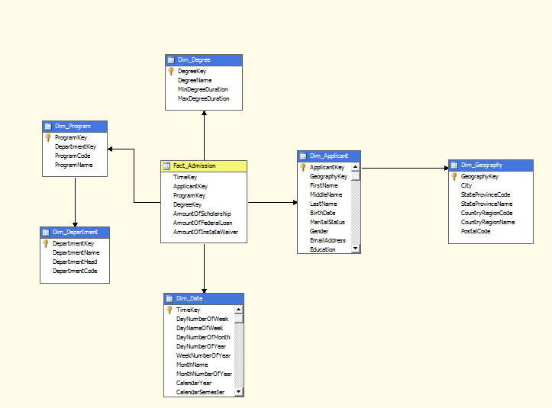

#### Hierarchies

Geography Hierarchy

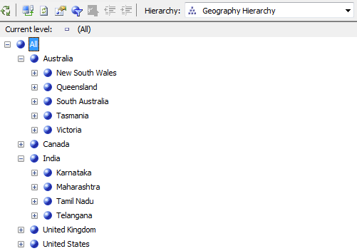

Date Hierarchy



#### Reports

**Business Question:** Compare the amount of Instate Wavier provided and amount of Federal Loan granted among various departments during the year 2003

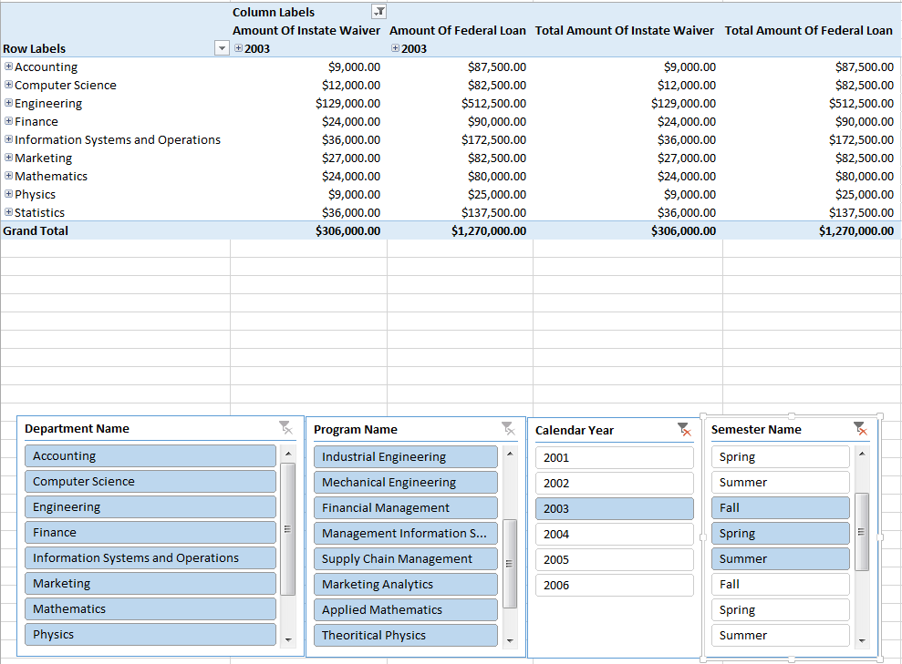

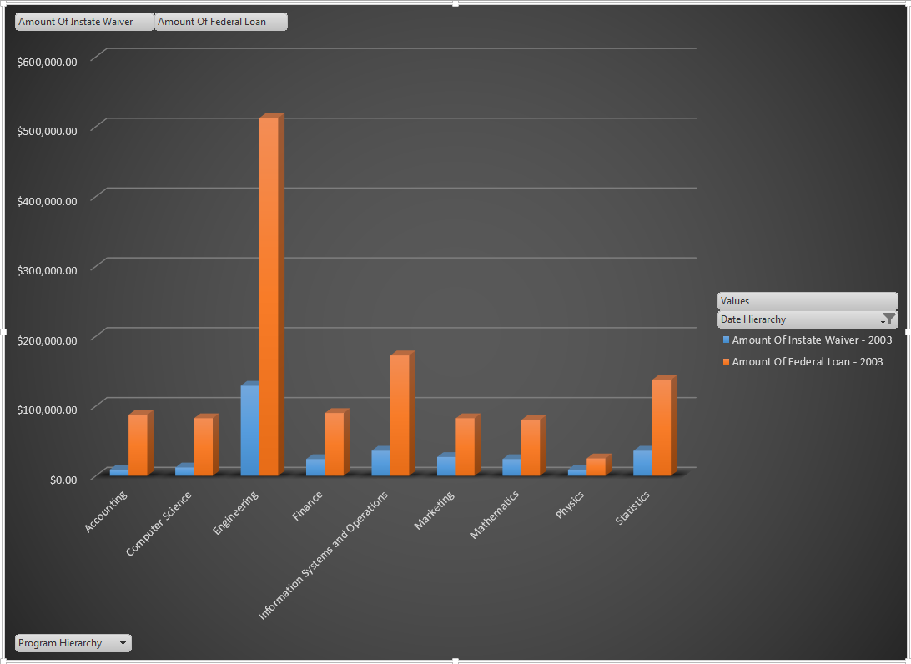

The above report helps in identifying the departments that sanction the highest amount of instate wavier. Also the management will be able to compare the amount of federal loan sanctioned to students of each department. These statistics can also be useful for strategic decision making on scholarship and funding allocation to departments.

### Course Registration

#### Cube Structure

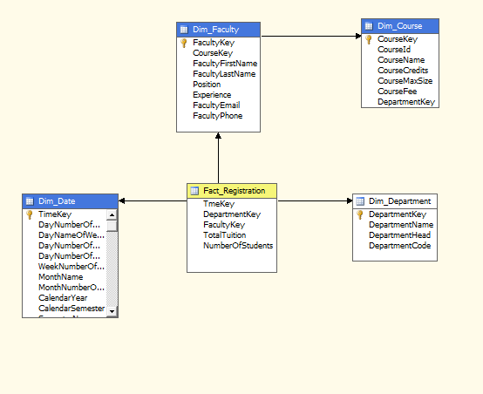

#### Hierarchies

Faculty Hierarchy

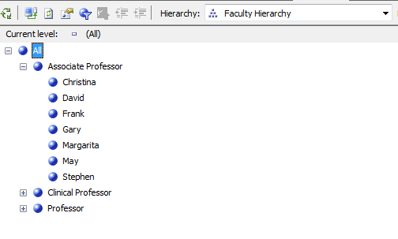

Date Hierarchy



#### Reports

**Business Question:** Find the number of students who have enrolled for Biostatistics-I, Introduction to Applied Bayesian Methods, Statistical Bioinformatics and Spatial Statistics under each professor taking the course during the year 2005.

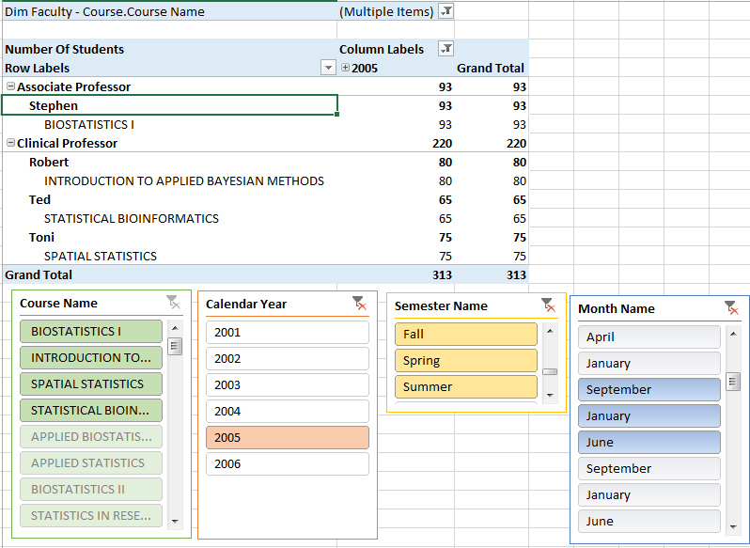

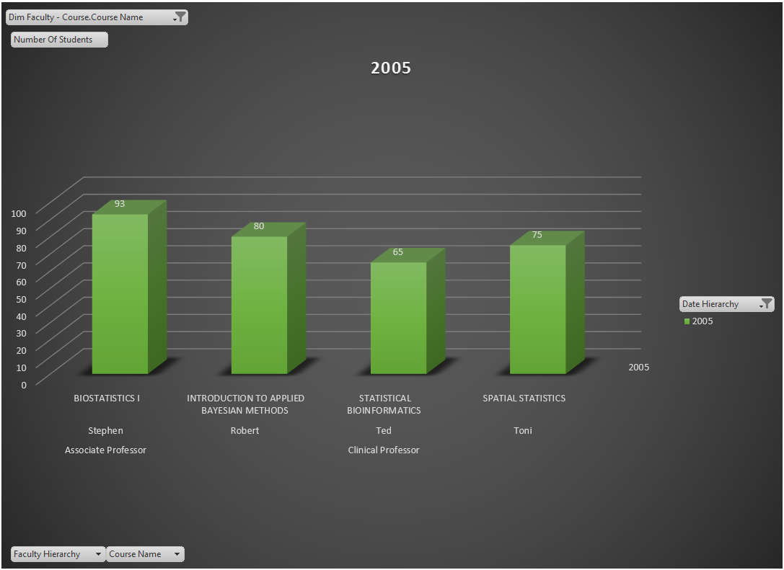

The above report gives a holistic view of the number of students who are registering for a particular course during a particular year. This piece of information can be really useful in understanding the preferences of students when it comes to course selection. The university will be able to allocate greater resources and personnel to courses that are more in demand. Besides, based on the preferences of students, the University can achieve a better academic planning.

### Placements

#### Cube Structure

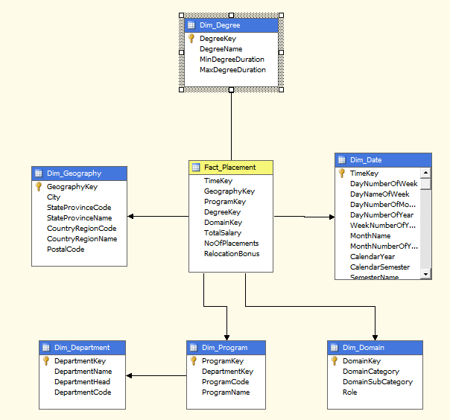

#### Hierarchies

Program Hierarchy

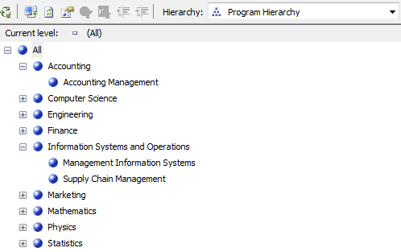

Geography Hierarchy

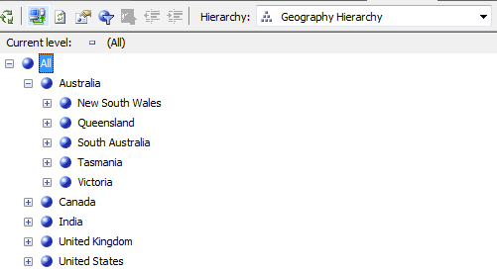

#### Reports

**Business Question:** Find the numberplacements in the field of **Information Technology** in the state of **Texas**

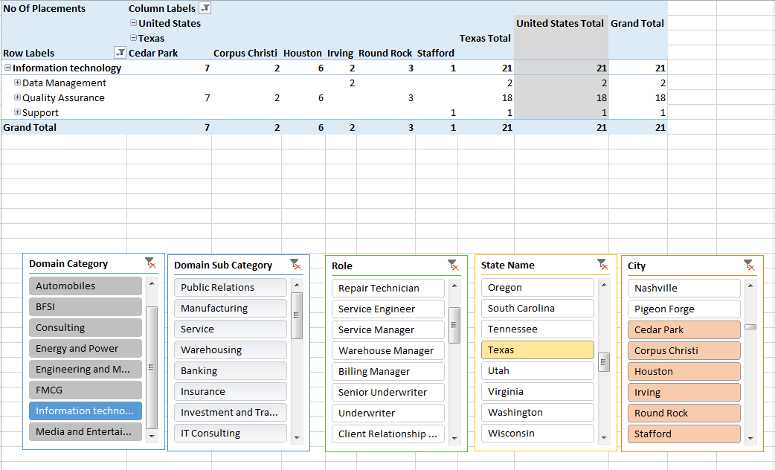

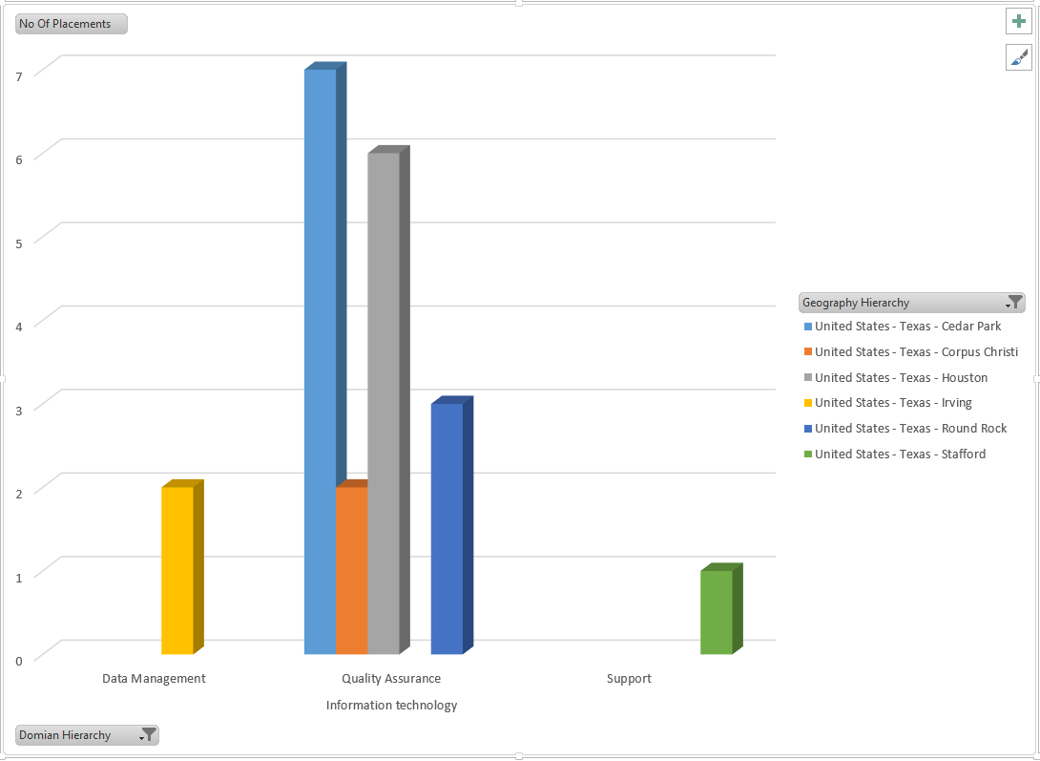

**Business Question:** Find and compare the average salary based on placements in each industry domain

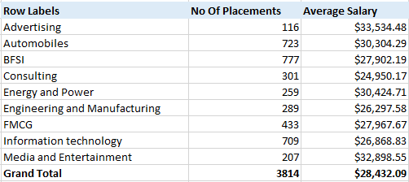

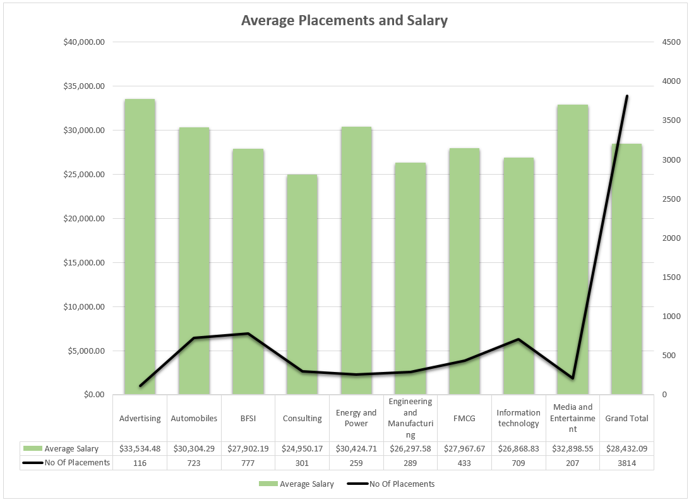

The above reports give an idea on the trends of placements. The university can also compare the placements and employment opportunities in various domain areas and accordingly improve their career guidance cell. Also these reports are also helpful for the analysis at each department level, for example, the number of placements and the average salary in the field of Information Technology is illustrated in the first graph. This graph provides insights into geographical locations and domain etc. This information can turn out to be a very valuable piece of information for prospective students as well.